**ES6**

class human{

constructor(){

this.age = 25;

}

printAge(){

console.log(this.age);//output:25

}

}

class person extends human{

constructor(){

super();

this.name = "abc";

this.age = 50;

}

printName(){

console.log(this.name)//output:50

}

}

const persons = new person();

persons.printName();

persons.printAge();

ES7

---------------

class human{

age = 25;

printAge = () => console.log(this.age)

}

class person extends human {

name = "abc";

age = 50;

printName = () => console.log(this.name);//output:abc 50

}

const persons = new person();

persons.printName();

persons.printAge();

**Spreat operator**

Array operator using spread operator

--------------------------------------------

set1 = [1,2,3,4,5]

set2 = [...set1,9,10,4]

console.log(set2);

**//output:** [

1, 2, 3, 4,

5, 9, 10, 4

]

Object using for spread operator

-------------------------------------------

set1 = {

name : "age",

email : "abc@gmail.com"

}

set2 = {

...set1,

age:20

}

console.log(set2);**// output:** { name: 'age', email: 'abc@gmail.com', age: 20 }

**Object Distructring**

values = [10,20,30];

[a,b,c] = values;

console.log(a,b,c);//output:10 30

values = {

email:"abc@gmail.com",

age : 25

}

console.log(values.email);

console.log(values.age);

using object destructuring

-------------------------------

values = {

email:"abc@gmail.com",

age : 25

}

const {email, age} = values

console.log(email);//output: abc@gmail.com

console.log(age);//output:25

RET operator

const array = (...arr) => console.log(arr);

array(10,20,30,40,50,60);//output: [ 10, 20, 30, 40, 50, 60 ]

const array = (a,...arr) => console.log(arr);

array(10,20,30,40,50,60);//**output**: [ 20, 30, 40, 50, 60 ]

const array = (a,b,...arr) => console.log(arr);

array(10,20,30,40,50,60);//**output**: [ 30, 40, 50, 60 ]

Arrays

let arr = [10,20,30,40];

arr.push(50);

console.log(arr);//**output:[ 10, 20, 30, 40, 50 ]**

let arr = [10,20,30,40];

arr.pop();

console.log(arr);//**output:[ 10, 20, 30 ]**

let arr = [10,20,30,40];

let index = 2;

arr.splice(index,1);

console.log(arr);//**output:[ 10, 20, 40 ]**

let arr = [10,20,30,40];

let index = arr.indexOf(20);

arr.splice(index,1);

console.log(arr**);//output:[** 10, 20, 40 ]

**React JS**

1.React core syntax & JSX

2.Working with components

3.Working with data2

Softwares for react:node version, vs code

Create react App:

npm install create-react-app

npx create-react-app project_name

npm start

rafc—for create function short hand(extends es7/react/redux)

rcc –for create class short hand

States and props

State—for initializing multiple variable and values

Props—for transferring 1 component to another component

Parent component –

State = {

Name : “Manjula”

}

<Display name={this.state.name}>

Child-component –

<h2>{this.props.name}</h2>

Styling Reactjs

Inline style –

We have to apply double curly brases

color:”white”,--common separator not semicolon

backgrounColor:”red”

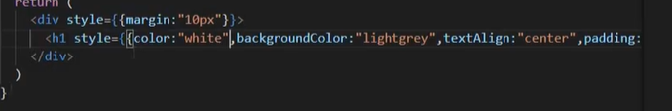



Onother method

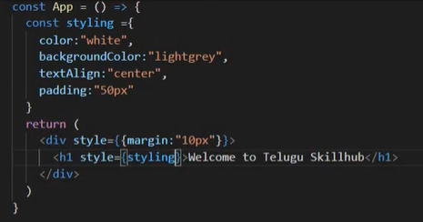

onClick Event Handler in react js

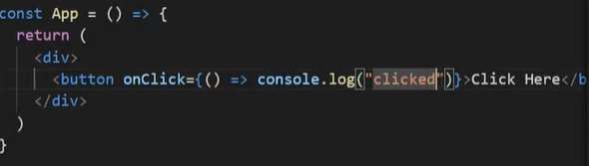

Before clicking

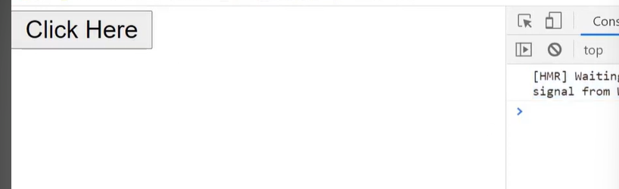

After clicking

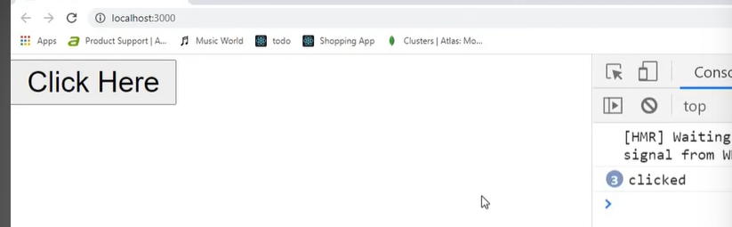

useState

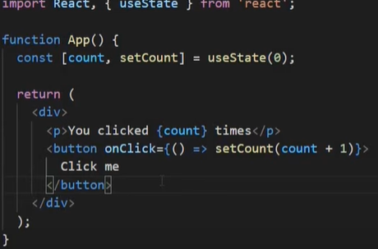

useEffect()

Its areal hook

Functional components used for useEffect after return it will excuted

It’s a Life cycle hook.

one after the another function calling

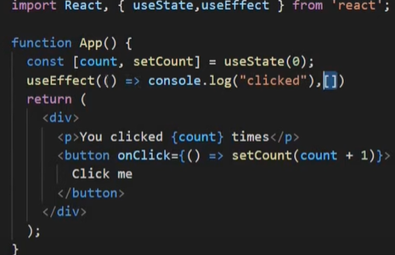

First I will return **clicked** (real dom excuted when comes to browsers)

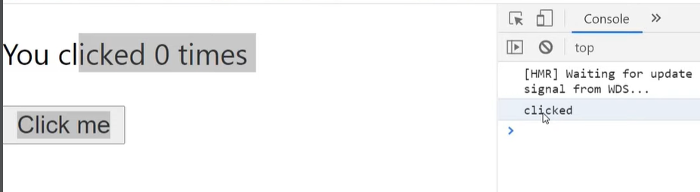

After clicking button clicked coming using useEffect

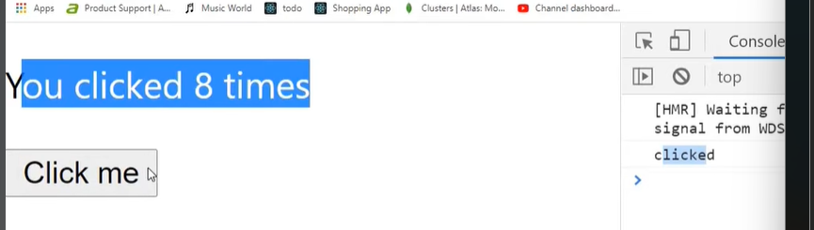

Using dependency

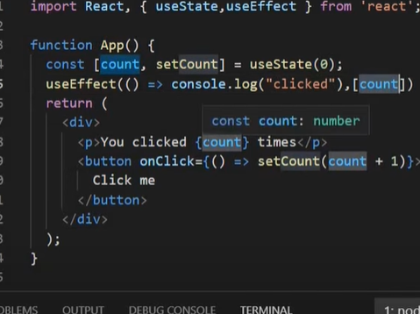

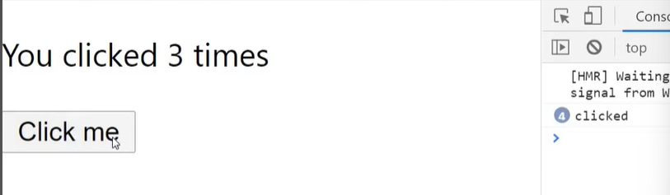

Dependency in class comoponent component did mount

Onchange Event Handler in React js

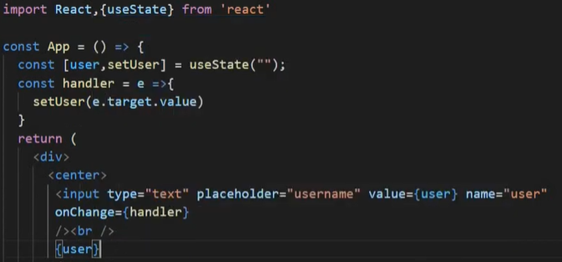

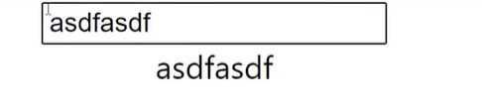

onSubmit event Handler in react js

Before using onsubmit 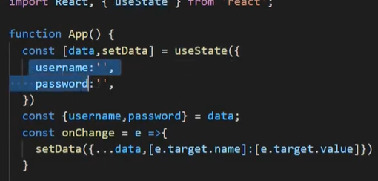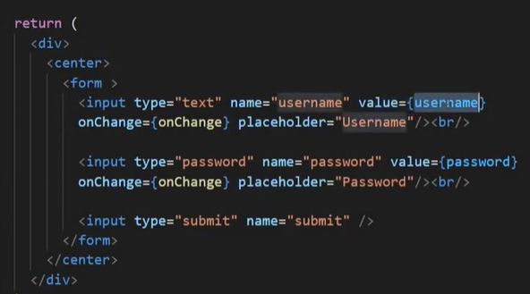

For using onchange,object ditructruring,use state then only onsubmit will work.

After using onsubmit

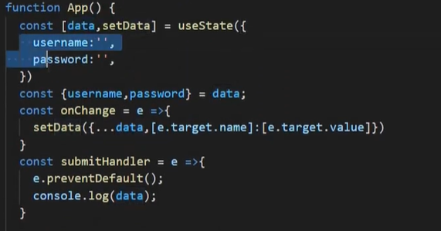

Console.log(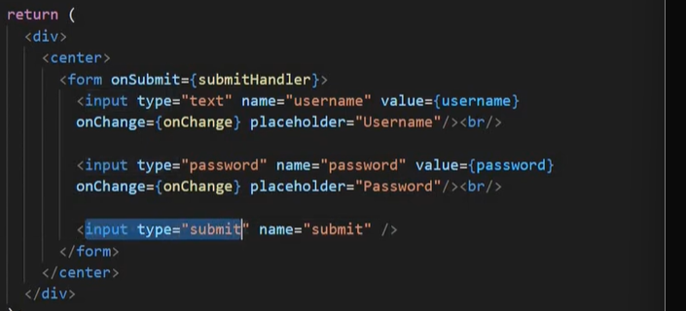

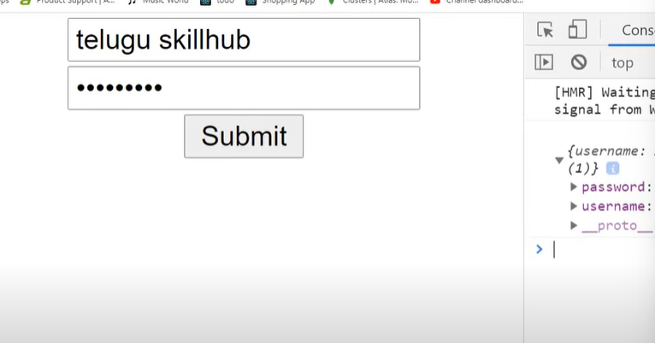

Map() function in react

.one array of values hidrated and print the individual component

one object of values hidrated and print the individual component

styntax:



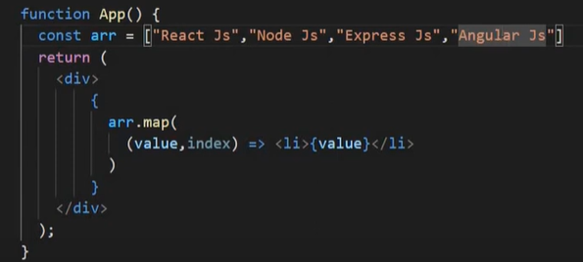 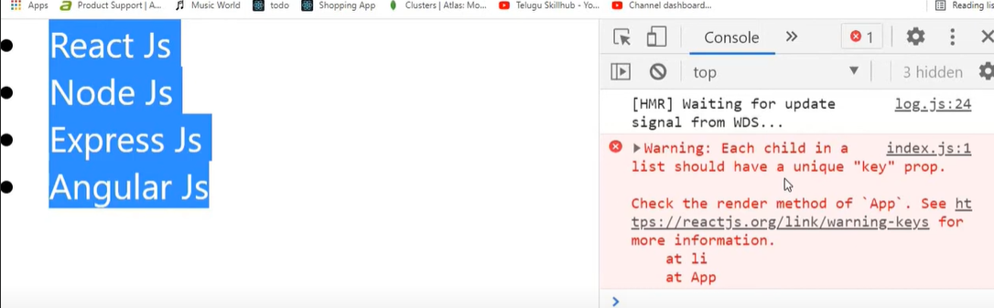

For getting error because of key property is used for unique value suppose if we are having duplicate values so we need to apply key property

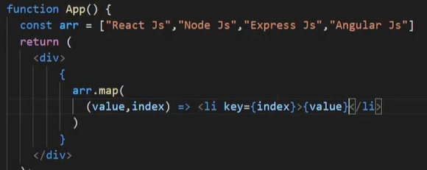 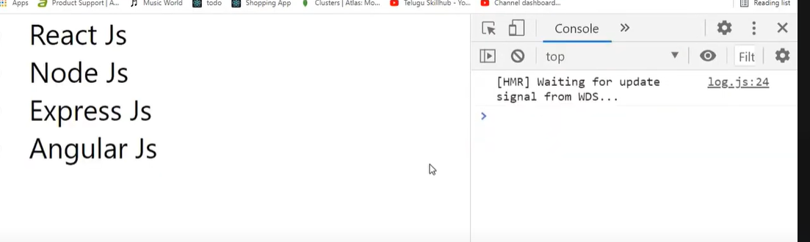

**Object of map**

**-----------------**

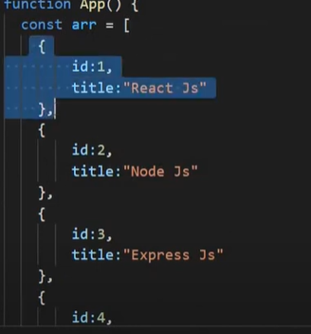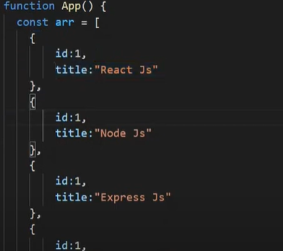

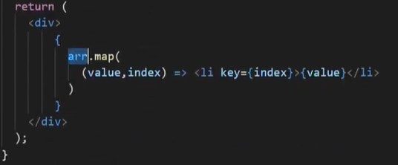

**Here (value,index) here index is not mandatory**

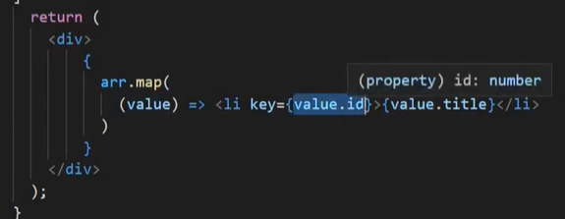 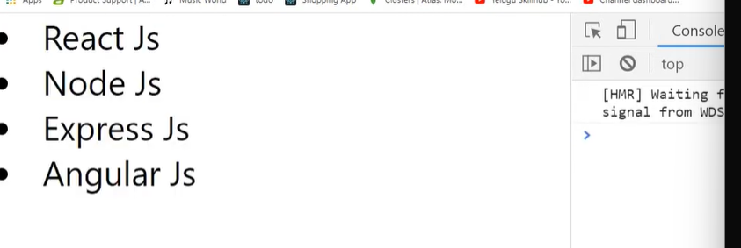

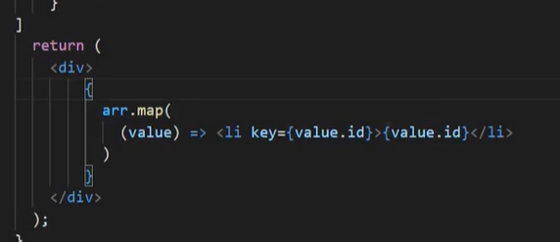

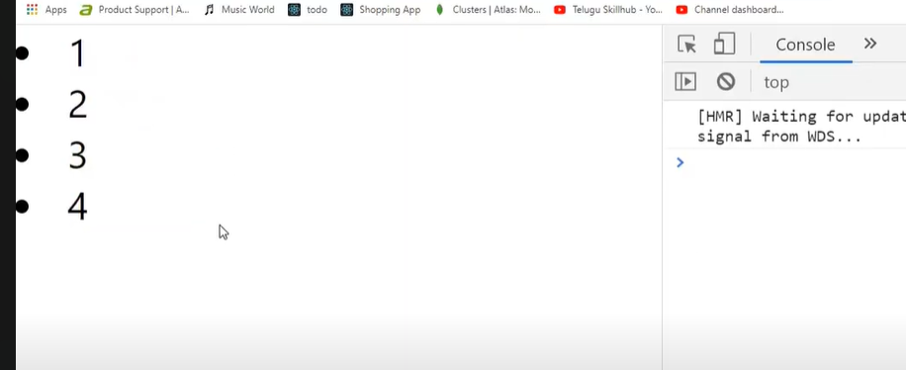

**Filter () function in react js**

**Syntax**



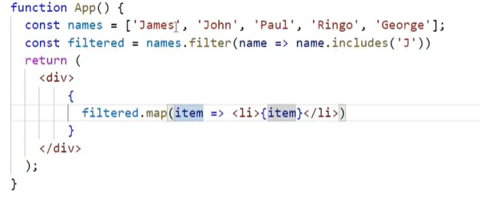

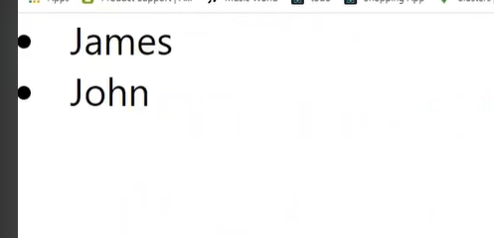

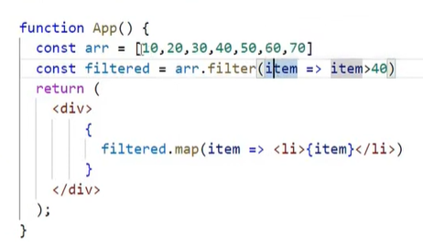

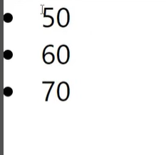

**Export vs export default**

**Syntax**

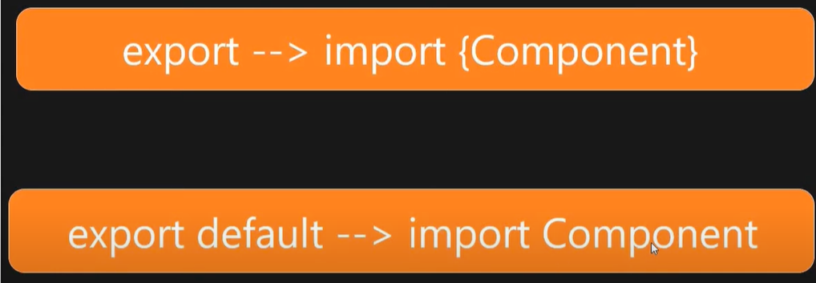

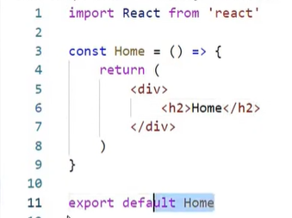

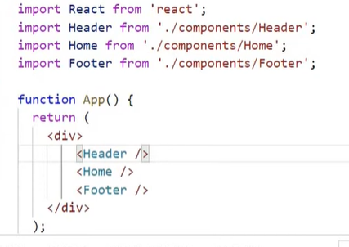

**Now using export only**

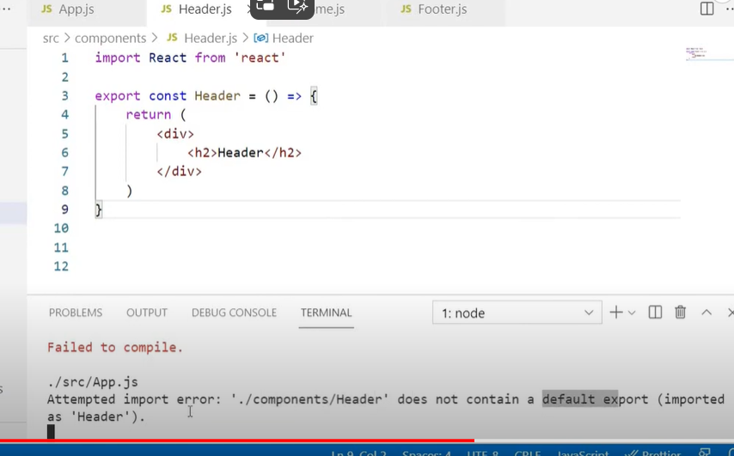 **so we have to import home like below code**

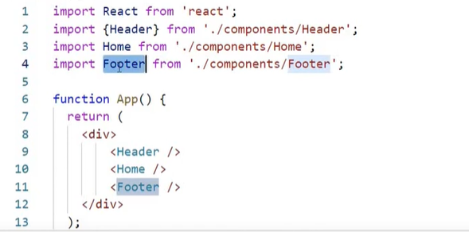

**Login form submit in reactjs**

**For first we need for creating the login submit form** 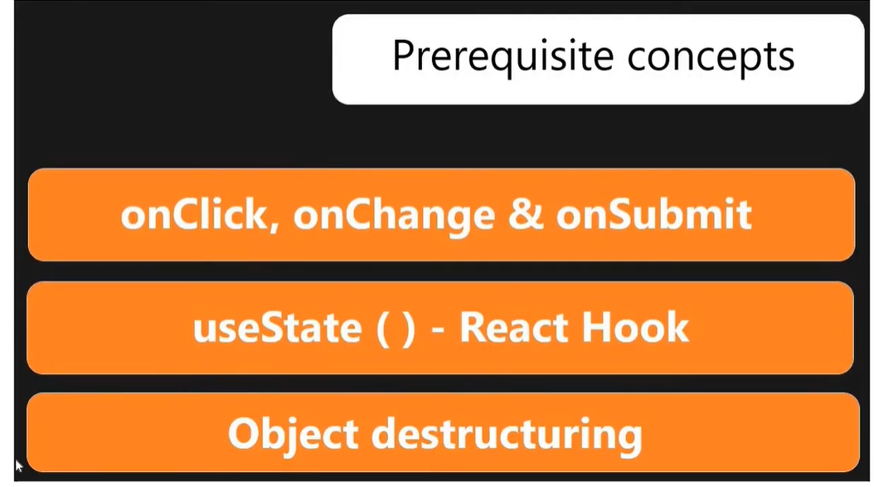

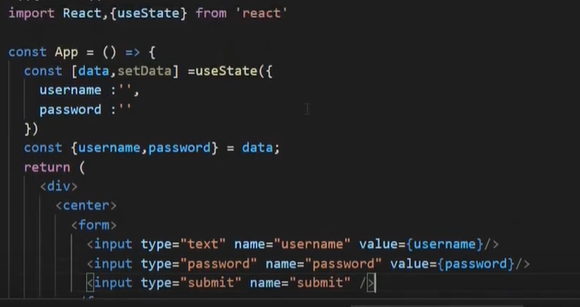

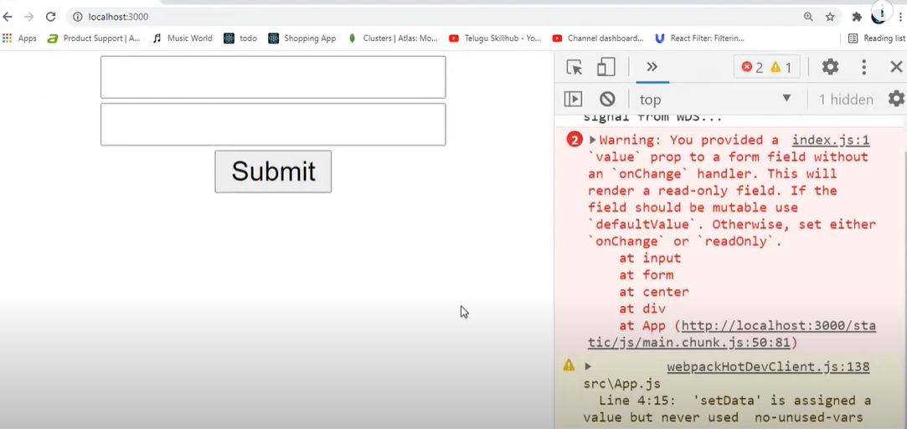

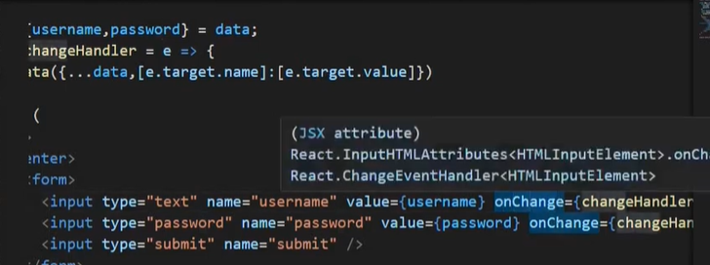

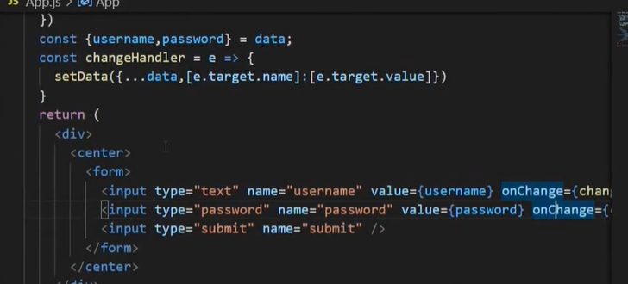

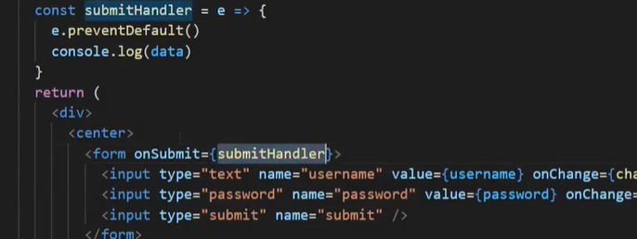

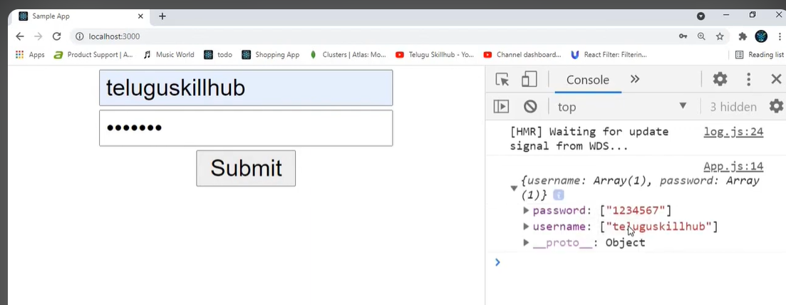

**Signup form submit in react js**



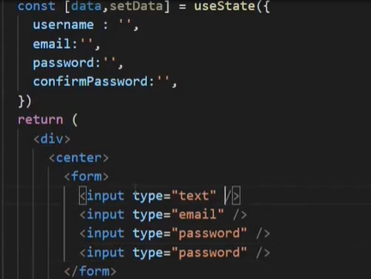

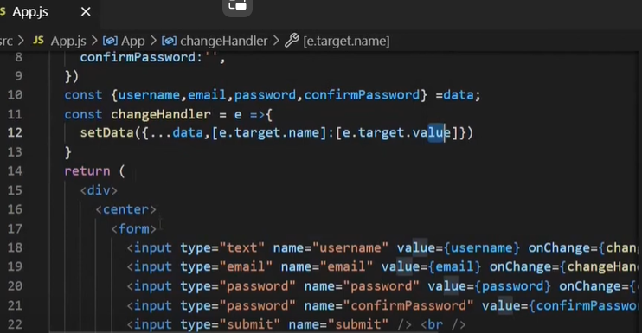

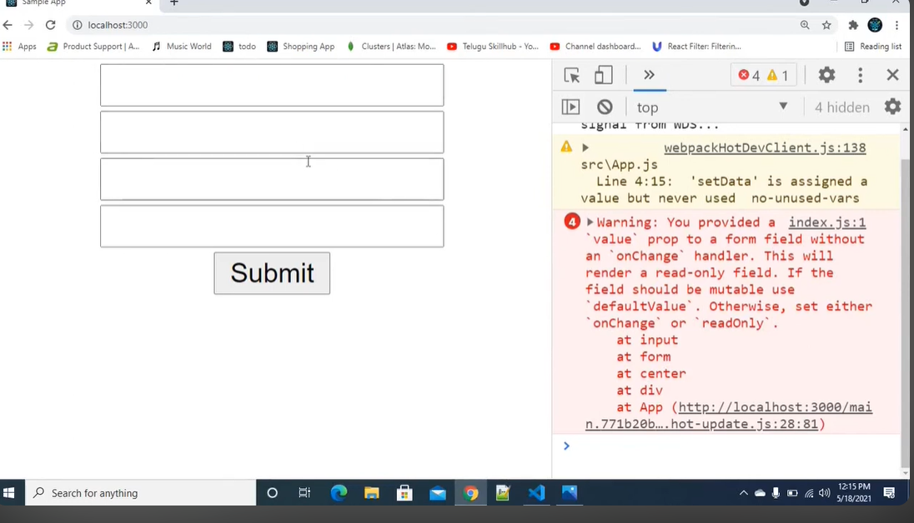

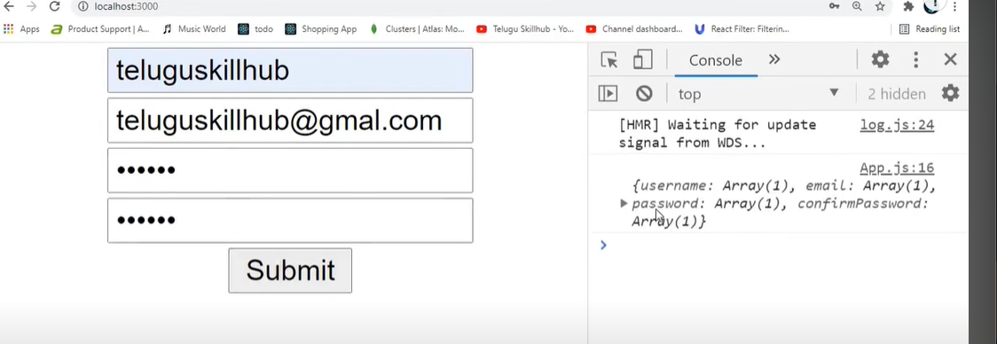

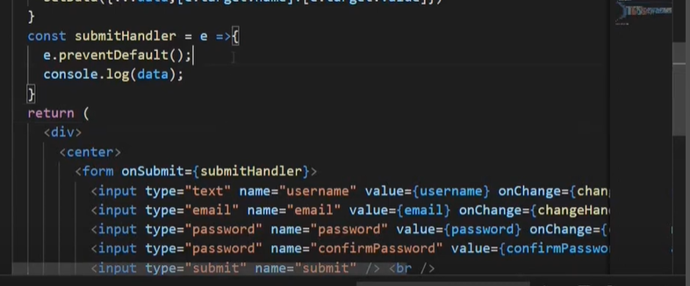



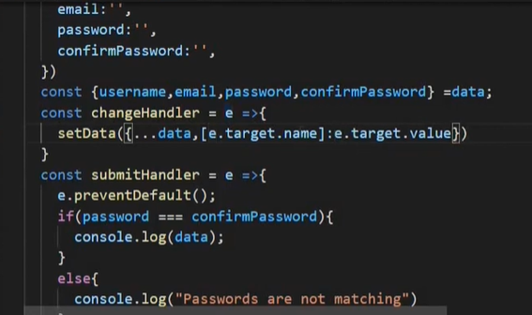

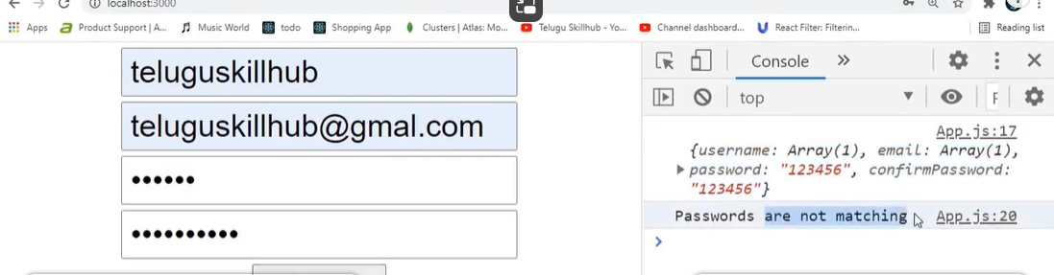

**Form validation for signup page**

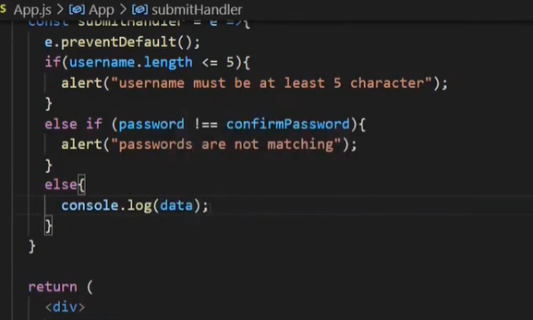

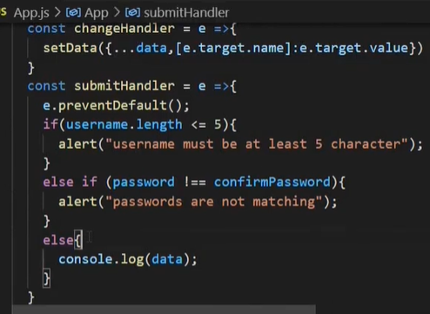

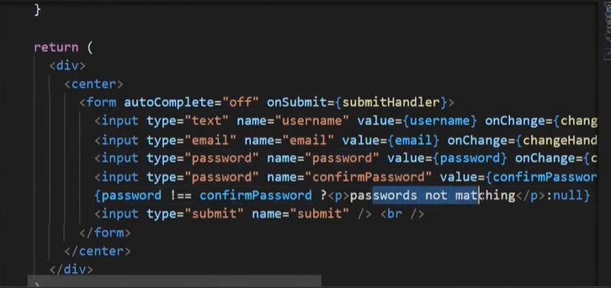

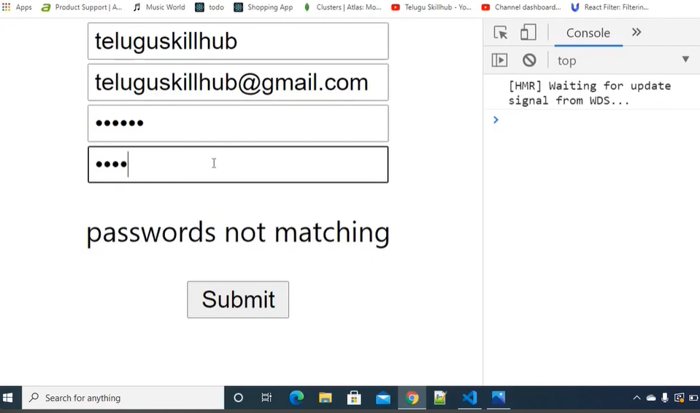

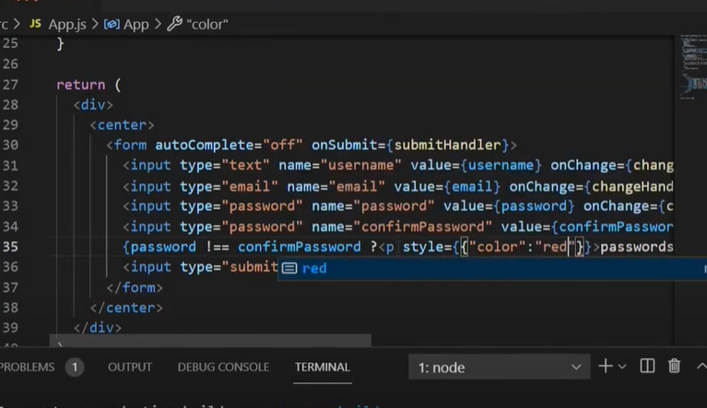

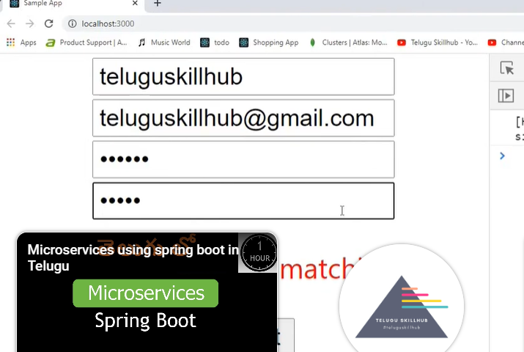

**Caluclator in reactjs**

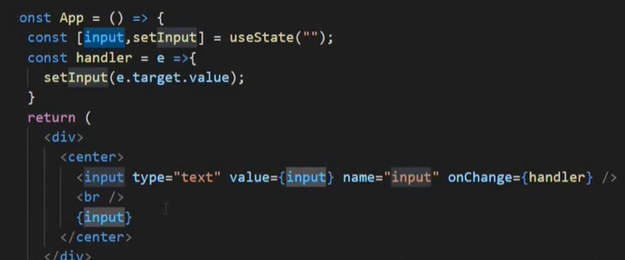

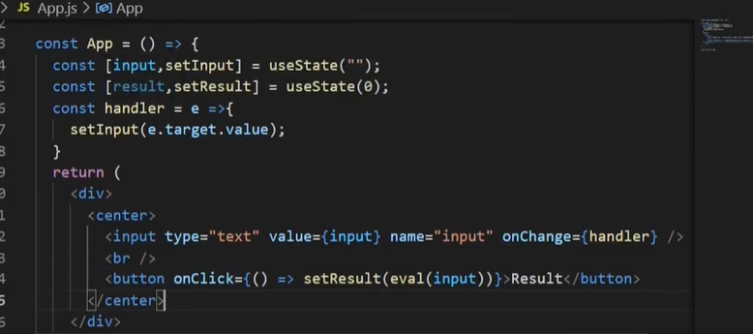

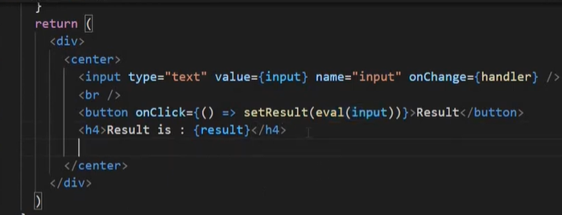

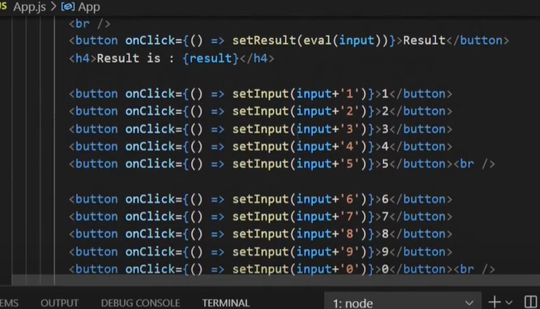

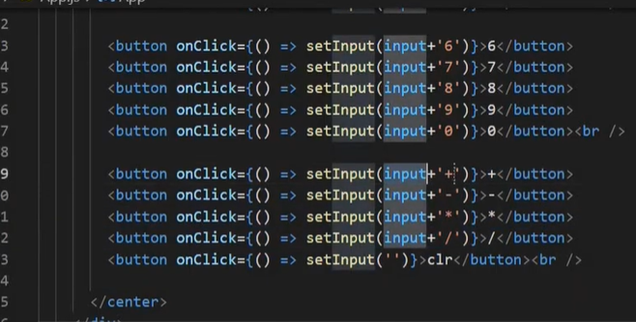

**Fetch() in react js**

**Where we use in any king of nested variables making at the same time certain amount of data to Access the url data**

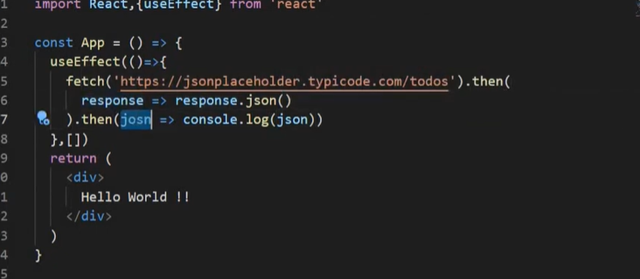

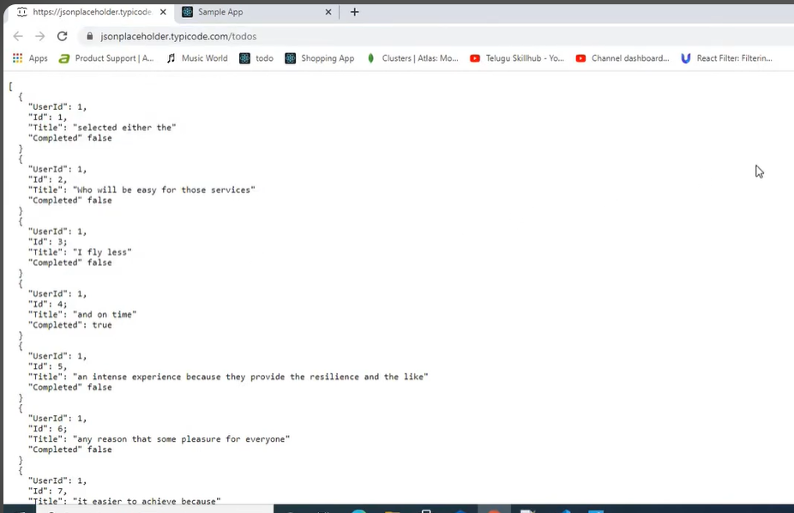

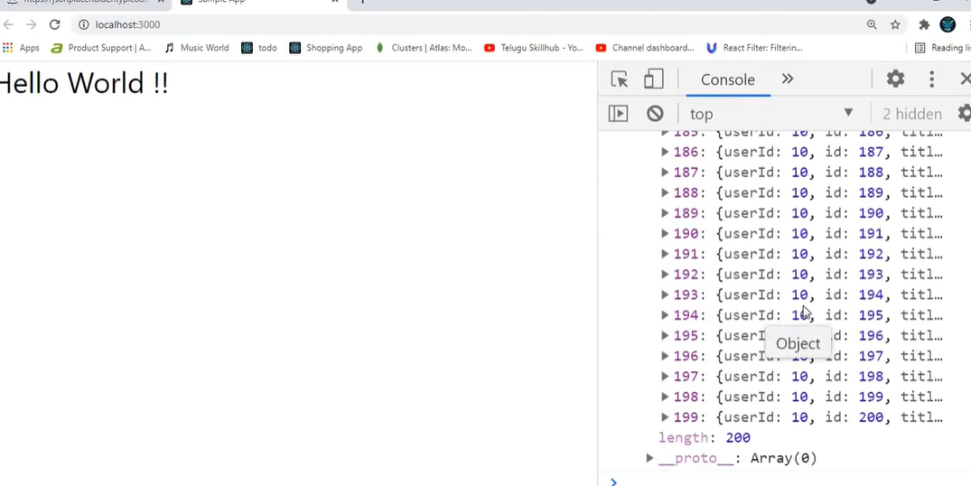

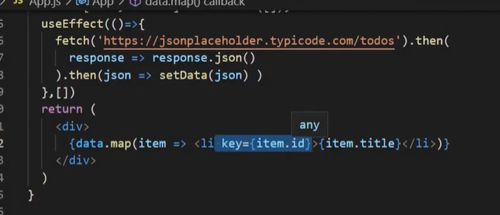

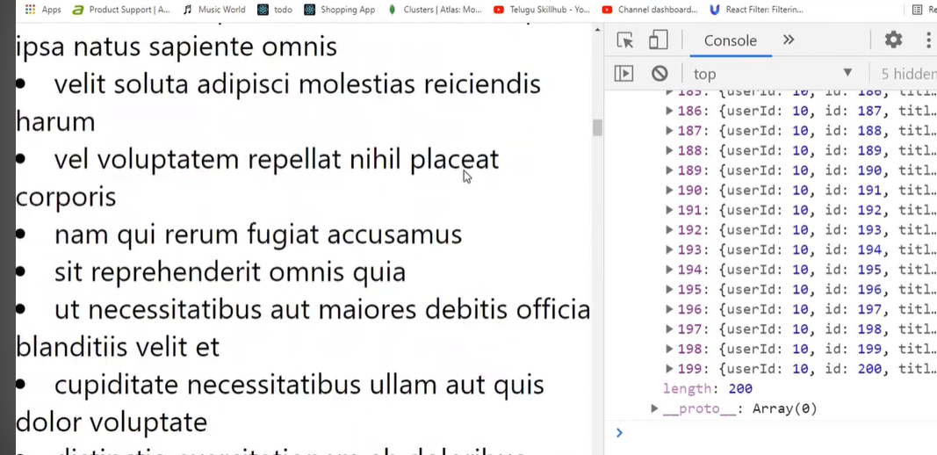

**Axios()in reactjs**



